TFM_E2_Grupo02

2023-06-08

library(dplyr)

##   
## Attaching package: 'dplyr'

## The following objects are masked from 'package:stats':  
##   
## filter, lag

## The following objects are masked from 'package:base':  
##   
## intersect, setdiff, setequal, union

library(factoextra)

## Loading required package: ggplot2

## Welcome! Want to learn more? See two factoextra-related books at https://goo.gl/ve3WBa

library(ggplot2)  
library(cluster)  
library(tidyverse)

## ── Attaching core tidyverse packages ──────────────────────── tidyverse 2.0.0 ──  
## ✔ forcats 1.0.0 ✔ stringr 1.5.0  
## ✔ lubridate 1.9.2 ✔ tibble 3.2.1  
## ✔ purrr 1.0.1 ✔ tidyr 1.3.0  
## ✔ readr 2.1.4

## ── Conflicts ────────────────────────────────────────── tidyverse_conflicts() ──  
## ✖ dplyr::filter() masks stats::filter()  
## ✖ dplyr::lag() masks stats::lag()  
## ℹ Use the conflicted package (<http://conflicted.r-lib.org/>) to force all conflicts to become errors

library(ggcorrplot)  
library(writexl)

## Warning: package 'writexl' was built under R version 4.3.1

library(openxlsx)

## Warning: package 'openxlsx' was built under R version 4.3.1

library(PerformanceAnalytics)

## Warning: package 'PerformanceAnalytics' was built under R version 4.3.1

## Loading required package: xts  
## Loading required package: zoo  
##   
## Attaching package: 'zoo'  
##   
## The following objects are masked from 'package:base':  
##   
## as.Date, as.Date.numeric  
##   
##   
## ######################### Warning from 'xts' package ##########################  
## # #  
## # The dplyr lag() function breaks how base R's lag() function is supposed to #  
## # work, which breaks lag(my_xts). Calls to lag(my_xts) that you type or #  
## # source() into this session won't work correctly. #  
## # #  
## # Use stats::lag() to make sure you're not using dplyr::lag(), or you can add #  
## # conflictRules('dplyr', exclude = 'lag') to your .Rprofile to stop #  
## # dplyr from breaking base R's lag() function. #  
## # #  
## # Code in packages is not affected. It's protected by R's namespace mechanism #  
## # Set `options(xts.warn_dplyr_breaks_lag = FALSE)` to suppress this warning. #  
## # #  
## ###############################################################################  
##   
## Attaching package: 'xts'  
##   
## The following objects are masked from 'package:dplyr':  
##   
## first, last  
##   
##   
## Attaching package: 'PerformanceAnalytics'  
##   
## The following object is masked from 'package:graphics':  
##   
## legend

library(corrplot)

## corrplot 0.92 loaded

library(ggplot2)  
library(car)

## Loading required package: carData  
##   
## Attaching package: 'car'  
##   
## The following object is masked from 'package:purrr':  
##   
## some  
##   
## The following object is masked from 'package:dplyr':  
##   
## recode

library(simstudy)

## Warning: package 'simstudy' was built under R version 4.3.1

library(data.table)

## Warning: package 'data.table' was built under R version 4.3.1

##   
## Attaching package: 'data.table'  
##   
## The following objects are masked from 'package:xts':  
##   
## first, last  
##   
## The following objects are masked from 'package:lubridate':  
##   
## hour, isoweek, mday, minute, month, quarter, second, wday, week,  
## yday, year  
##   
## The following object is masked from 'package:purrr':  
##   
## transpose  
##   
## The following objects are masked from 'package:dplyr':  
##   
## between, first, last

library(corrr)

## Warning: package 'corrr' was built under R version 4.3.1

#install.packages("dbscan")  
library(dbscan)

## Warning: package 'dbscan' was built under R version 4.3.1

##   
## Attaching package: 'dbscan'  
##   
## The following object is masked from 'package:stats':  
##   
## as.dendrogram

library(DMwR2)

## Warning: package 'DMwR2' was built under R version 4.3.1

## Registered S3 method overwritten by 'quantmod':  
## method from  
## as.zoo.data.frame zoo   
##   
## Attaching package: 'DMwR2'  
##   
## The following object is masked from 'package:dbscan':  
##   
## kNN

library(FactoMineR)  
library(factoextra)  
library(ggthemes)

## Warning: package 'ggthemes' was built under R version 4.3.1

#cargamos los datos con las variables que nos interesan  
#df1 = data.frame(read.csv2('C:/Users/linfante/OneDrive/Documentos/MasterBigData/TFM/tfm_master_ds/1 - BackEnd/Datos/alimentos v3.csv', sep=','))  
#df2 = data.frame(read.csv2('C:/Users/linfante/OneDrive/Documentos/MasterBigData/TFM/tfm_master_ds/1 - BackEnd/Datos/alimentos_vegan.csv', sep=','))  
df = data.frame(read.csv2('C:/Users/linfante/OneDrive/Documentos/MasterBigData/TFM/tfm_master_ds/1 - BackEnd/Datos/alimentos v7.csv', sep=','))

# Selecciona columnas a investigar y Elimina registros duplicados

df <- df[,c("ISO3","PRODUCT_NAME","ENERGY_100G","FAT_100G","CARBOHYDRATES_100G","PROTEINS_100G")]  
#df <- df[,c("PRODUCT_NAME","PROTEINS_100G","CARBOHYDRATES_100G","FAT_100G")]  
# Elimina registros duplicados  
df <- subset(df, !duplicated(df))

PRODUCT_NAME <- df[,"PRODUCT_NAME"]  
ISO3 <- df[,"ISO3"]  
 #Convertir a numerico todo  
df_nuevo <- df %>%  
 mutate(across(where(is.character), type.convert, as.is = TRUE)) %>%  
 select_if(is.numeric)

## Warning: There was 1 warning in `mutate()`.  
## ℹ In argument: `across(where(is.character), type.convert, as.is = TRUE)`.  
## Caused by warning:  
## ! The `...` argument of `across()` is deprecated as of dplyr 1.1.0.  
## Supply arguments directly to `.fns` through an anonymous function instead.  
##   
## # Previously  
## across(a:b, mean, na.rm = TRUE)  
##   
## # Now  
## across(a:b, \(x) mean(x, na.rm = TRUE))

PRODUCT_NAME <- df[,"PRODUCT_NAME"]  
df_nuevo <- cbind(ISO3,PRODUCT_NAME,df_nuevo)

# Eliminar vectores fila nulos

# Sumar las columnas del dataframe  
suma_columnas <- rowSums(df_nuevo[,3:ncol(df_nuevo)])  
  
# Agregar la variable de suma al dataframe  
df_nuevo <- cbind(df_nuevo, suma = suma_columnas)  
  
df_nuevo <- subset(df_nuevo, suma != 0)  
df_nuevo <- df_nuevo[, -which(names(df_nuevo) == "suma")]  
  
cantidad_ceros_por_columna <- colSums(df_nuevo == 0)  
  
print(cantidad_ceros_por_columna)

## ISO3 PRODUCT_NAME ENERGY_100G FAT_100G   
## 0 0 38 314   
## CARBOHYDRATES_100G PROTEINS_100G   
## 222 166

# Aplicar filtros negativos

# Crear un vector con las palabras a buscar  
palabras_a_eliminar <- c("SALSA DE SOJA","SAUCE SOJA", "SAUCE SOJA","BEBIDA DE SOJA", "YAOURT SOJA","YOGURT DE SOJA","CHOCOLAT","ARROZ Y SOJA","LECHE","MOUSSE","MILK","ACEITE","DESSERT","PAN SOJA","BOISSON SOJA", "GLACE","ML","SAUCE DE SOJA","SAUCE","SALSA","BIBEDA DE SOJA","LAIT SOJA","VIVESOY SOJA","LAIT DE SOJA","YAOURT","POSTRE","MUESLI","YOGUR","BEBIDA","MARGARINA","VINAIGRETTE","DRINK","SAUCE","BATIDO","LAIT","MAYONNAISE","CAFE","VANILLE","NATA","YOGURT","LACTOVISOY","ALIMENTO DE SOYA","ALIMENTO LIQUIDO DE SOYA")  
  
# Crear una función que verifica si alguna de las palabras está presente en el texto  
verificar_palabras <- function(texto, palabras) {  
 sapply(palabras, function(palabra) grepl(palabra, texto))  
}  
# Identificar las filas que contienen alguna de las palabras a eliminar  
filas_a_eliminar <- apply(df_nuevo, 1, function(row) any(verificar_palabras(row["PRODUCT_NAME"], palabras_a_eliminar)))  
  
# Eliminar las filas identificadas del dataframe original  
df_nuevo1 <- df_nuevo[!filas_a_eliminar, ]  
#df_nuevo2 <- df_nuevo1[,-1]  
  
#Elimino los faltantes  
df_nuevo1 <- df_nuevo1[complete.cases(df_nuevo1), ]

df_soja <- subset(df_nuevo1, grepl("soja", PRODUCT_NAME, ignore.case = TRUE)) ## Registros que contienen la palabra "soja"  
df_soja <- na.omit(df_soja)  
  
df_seitan <- subset(df_nuevo1, grepl("seitan", PRODUCT_NAME, ignore.case = TRUE)) ## Registros que contienen la palabra "seitan"  
df_seitan <- na.omit(df_seitan)  
  
df_tofu <- subset(df_nuevo1, grepl("tofu", PRODUCT_NAME, ignore.case = TRUE)) ## Registros que contienen la palabra "tofu"  
df_tofu <- na.omit(df_tofu)

# Frecuencia de productos por país de orígen

print(table(df_seitan$ISO3))

##   
## AND AUT BEL CAN CHE CZE DEU DZA ESP FIN FRA GBR HRV IRL ISR ITA JPN LUX MLT NLD   
## 1 2 39 10 26 4 57 1 144 2 144 7 2 2 2 122 1 2 1 5   
## PRT ROU SWE USA   
## 3 1 2 44

print(table(df_tofu$ISO3))

##   
## AND ARG AUS AUT BEL BGR BRA CAN CHE CHL CUB CZE DEU DNK ESP FIN FRA GBR HKG   
## 1 2 2 64 28 65 2 2 158 149 1 1 43 225 2 332 13 656 77 2   
## HRV HUN IND IRL ISR ITA JPN KEN LUX MEX MLT MUS NCL NLD NZL POL PRT PYF REU ROU   
## 3 4 2 43 2 180 11 1 2 5 1 1 2 13 2 14 10 6 4 11   
## SGP SVK SVN SWE THA UKR URY USA VIR   
## 7 6 1 13 1 1 1 400 1

print(table(df_soja$ISO3))

##   
## AND ARG AUS AUT BEL BOL BRA BRN CAN CHE CHL CHN CIV CZE DEU   
## 3 2 17 3 29 100 2 26 1 5 62 1 1 1 2 223   
## DNK DZA ESP FIN FRA GBR HRV HUN IRL ITA JPN KHM LUX MDG MEX NLD   
## 3 1 392 4 1259 9 1 1 33 30 5 1 9 1 1 14   
## NOR NZL POL PRT PYF REU ROU SAU SEN SLV SWE THA URY USA   
## 1 1 4 23 1 1 2 1 1 1 6 1 4 18

# SEITAN

# Aplicar algoritmo Local Outliers Factor para eliminar atípicos  
  
# 1.- First, we need to convert the incorrect type of variables.  
  
seitan_clean <- df_seitan %>%  
 mutate(PRODUCT_NAME = as.factor(PRODUCT_NAME))  
str(seitan_clean)

## 'data.frame': 624 obs. of 6 variables:  
## $ ISO3 : chr "USA" "USA" "USA" "USA" ...  
## $ PRODUCT_NAME : Factor w/ 451 levels "2 CRISP CRUMBED SEITAN SLICES",..: 407 407 407 67 67 375 197 197 156 415 ...  
## $ ENERGY_100G : num 587 519 640 628 738 732 551 551 661 398 ...  
## $ FAT_100G : num 1.75 1.77 3.53 2.21 2.94 ...  
## $ CARBOHYDRATES_100G: num 6.14 4.42 7.06 7.96 10.59 ...  
## $ PROTEINS_100G : num 24.6 24.8 25.9 26.6 27.1 ...

seitan_clean <- as.data.frame(scale(df_seitan[,-1:-2]))  
seitan_lof <- lof(seitan_clean, minPts = 7)  
head(seitan_clean)

## ENERGY_100G FAT_100G CARBOHYDRATES_100G PROTEINS_100G  
## 78 -0.5521054 -0.7131746 -0.50641464 0.2729566  
## 83 -0.7550831 -0.7106072 -0.73501417 0.2922927  
## 84 -0.3939022 -0.4210450 -0.38438150 0.3898047  
## 85 -0.4297218 -0.6381919 -0.26463383 0.4488568  
## 86 -0.1013754 -0.5178510 0.08459036 0.4938623  
## 87 -0.1192852 -0.2794073 0.19245894 0.2728328

#PCA and use the first two dimensions of the PCA  
library(FactoMineR)  
library(factoextra)  
  
seitan_pca <- PCA(seitan_clean, scale.unit = F, ncp = 6, graph = F)

summary(seitan_pca)

##   
## Call:  
## PCA(X = seitan_clean, scale.unit = F, ncp = 6, graph = F)   
##   
##   
## Eigenvalues  
## Dim.1 Dim.2 Dim.3 Dim.4  
## Variance 1.719 1.205 0.797 0.272  
## % of var. 43.050 30.175 19.962 6.813  
## Cumulative % of var. 43.050 73.225 93.187 100.000  
##   
## Individuals (the 10 first)  
## Dist Dim.1 ctr cos2 Dim.2 ctr cos2   
## 78 | 1.070 | -0.922 0.079 0.743 | 0.516 0.035 0.233 |  
## 83 | 1.304 | -1.161 0.126 0.793 | 0.578 0.044 0.197 |  
## 84 | 0.795 | -0.580 0.031 0.533 | 0.515 0.035 0.420 |  
## 85 | 0.929 | -0.649 0.039 0.488 | 0.571 0.043 0.377 |  
## 86 | 0.728 | -0.190 0.003 0.069 | 0.506 0.034 0.484 |  
## 87 | 0.451 | -0.078 0.001 0.030 | 0.204 0.006 0.205 |  
## 392 | 1.053 | -0.976 0.089 0.859 | 0.315 0.013 0.089 |  
## 393 | 1.053 | -0.976 0.089 0.859 | 0.315 0.013 0.089 |  
## 394 | 1.054 | -0.649 0.039 0.379 | 0.778 0.081 0.546 |  
## 395 | 1.653 | -1.619 0.244 0.960 | 0.256 0.009 0.024 |  
## Dim.3 ctr cos2   
## 78 0.154 0.005 0.021 |  
## 83 -0.012 0.000 0.000 |  
## 84 0.050 0.001 0.004 |  
## 85 0.292 0.017 0.099 |  
## 86 0.466 0.044 0.411 |  
## 87 0.354 0.025 0.617 |  
## 392 0.220 0.010 0.044 |  
## 393 0.220 0.010 0.044 |  
## 394 0.271 0.015 0.066 |  
## 395 0.182 0.007 0.012 |  
##   
## Variables  
## Dim.1 ctr cos2 Dim.2 ctr cos2 Dim.3  
## ENERGY_100G | 0.897 46.846 0.807 | 0.249 5.157 0.062 | 0.020  
## FAT_100G | 0.680 26.915 0.463 | -0.320 8.480 0.102 | -0.625  
## CARBOHYDRATES_100G | 0.607 21.420 0.369 | -0.446 16.476 0.199 | 0.631  
## PROTEINS_100G | 0.288 4.819 0.083 | 0.918 69.887 0.844 | 0.083  
## ctr cos2   
## ENERGY_100G 0.053 0.000 |  
## FAT_100G 49.071 0.392 |  
## CARBOHYDRATES_100G 50.009 0.399 |  
## PROTEINS_100G 0.867 0.007 |

fviz_eig(seitan_pca, ncp = 6, addlabels = T, main = "Variance explained by each dimensions - Seitan")

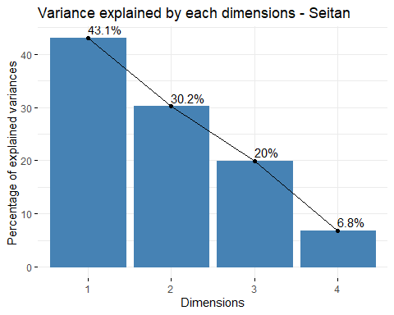

library(ggthemes)  
seitan_a <- data.frame(seitan_pca$ind$coord[,1:3])  
seitan_b <- cbind(seitan_a, lof_score = seitan_lof)  
#seitan_b <- cbind(seitan_a, fraud = seitan_clean$, lof_score = seitan_clean$lof)  
  
seitan_lof_visual <- ggplot(seitan_b, aes(x=Dim.1 ,y=Dim.2)) +   
 geom_point(aes(size=lof_score)) +  
 ggtitle("LOF Score Distribution - Seitan")+  
 theme_minimal()  
  
seitan_lof_visual

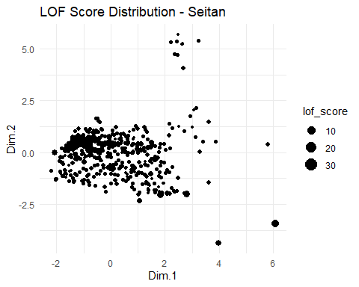

summary(seitan_b)

## Dim.1 Dim.2 Dim.3 lof_score   
## Min. :-2.2051 Min. :-4.37419 Min. :-8.2367 Min. :0.9126   
## 1st Qu.:-0.9834 1st Qu.:-0.68423 1st Qu.:-0.3688 1st Qu.:1.0014   
## Median :-0.3252 Median : 0.06254 Median :-0.0602 Median :1.0707   
## Mean : 0.0000 Mean : 0.00000 Mean : 0.0000 Mean : Inf   
## 3rd Qu.: 0.8360 3rd Qu.: 0.55616 3rd Qu.: 0.3935 3rd Qu.:1.2404   
## Max. : 6.0740 Max. : 5.68950 Max. : 5.4533 Max. : Inf

seitan_b %>%  
 filter(lof_score <= 1.75) %>%   
 ggplot( aes(x=lof_score)) +  
 geom_density( color="#e9ecef", fill = "#c90076", alpha=0.7) +  
 scale_fill_manual(values="#8fce00") +  
 xlab("LOF Score")+  
 ggtitle("LOF Score Distribution Seitan")+  
 theme_minimal() +  
 labs(fill="")

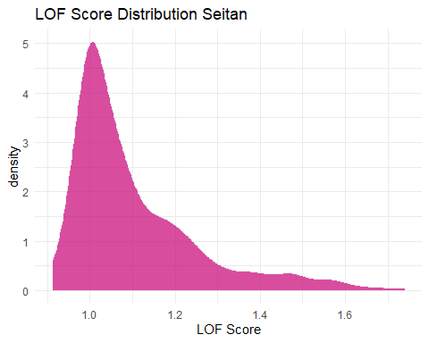

quantile(seitan_b$lof_score, probs = c(0, 0.8))

## 0% 80%   
## 0.9125573 1.3319969

seitan_b <- seitan_b %>%   
 mutate(outlier = ifelse(lof_score > 1.3319969, 1, 0))  
  
seitan_lof_visual_b <- ggplot(seitan_b, aes(x=Dim.1 ,y=Dim.2, color=outlier)) +   
 geom_point() +  
 ggtitle("LOF Score Distribution Seitan")+  
 theme_minimal()  
  
seitan_lof_visual_b

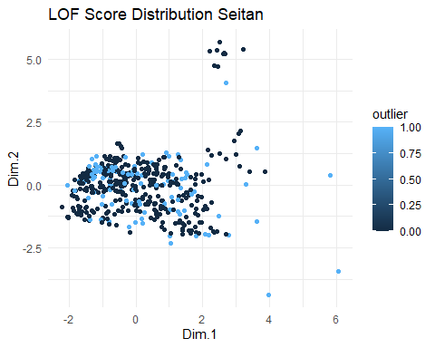

outliers <- seitan_b[seitan_b$outlier==1,]  
nooutliers <- seitan_b[seitan_b$outlier==0,]

df_seitan <- df_seitan[seitan_lof < 1.3319969,]  
df_seitan_outliers <- df_seitan[seitan_lof >= 1.3319969,]

# Eliminar valores atipicos univariantes

remove_outliers <- function(data, column, sd_threshold = 2) {  
 data[abs(scale(data[[column]])) < sd_threshold, ]  
}  
  
columns_to_check <- 3:ncol(df_seitan)  
for (column in columns_to_check) {  
 df_seitan <- remove_outliers(df_seitan, column)  
}

# Obtener las columnas cuantitativas del dataframe  
columnas_cuantitativas <- sapply(df_seitan, is.numeric)  
  
# Crear un histograma para cada columna cuantitativa  
for (columna in names(df_seitan[columnas_cuantitativas])) {  
 plot_data <- df_seitan[, columna]  
 p <- ggplot(data.frame(x = plot_data), aes(x)) +  
 geom_histogram(binwidth = 0.5, fill = "steelblue", color = "white") +  
 labs(title = paste("Histograma de", columna,"- Seitan"),  
 x = columna,  
 y = "Frecuencia")  
   
 print(p)  
}

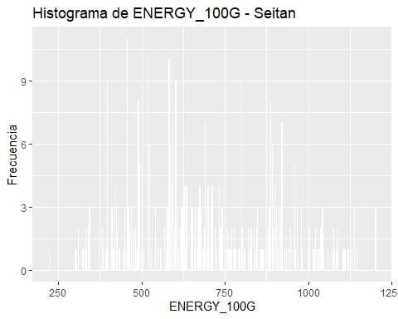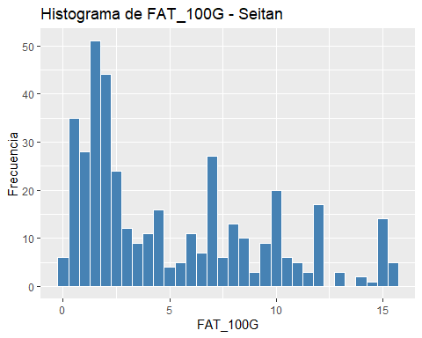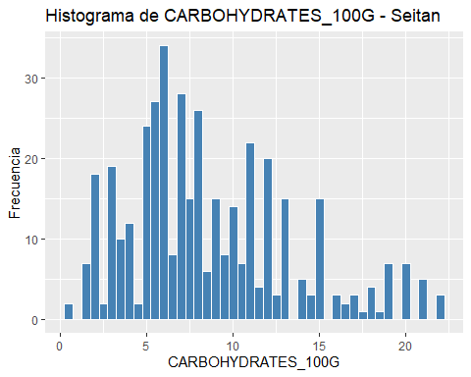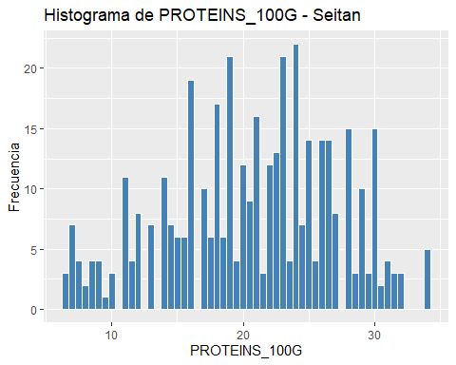

summary(as.data.frame(scale(df_seitan[,-1:-2])))

## ENERGY_100G FAT_100G CARBOHYDRATES_100G PROTEINS_100G   
## Min. :-2.1889 Min. :-1.1914 Min. :-1.7133 Min. :-2.2511   
## 1st Qu.:-0.8173 1st Qu.:-0.8407 1st Qu.:-0.6554 1st Qu.:-0.7415   
## Median :-0.1246 Median :-0.3731 Median :-0.2111 Median : 0.0448   
## Mean : 0.0000 Mean : 0.0000 Mean : 0.0000 Mean : 0.0000   
## 3rd Qu.: 0.8775 3rd Qu.: 0.7257 3rd Qu.: 0.5284 3rd Qu.: 0.7446   
## Max. : 2.3322 Max. : 2.4557 Max. : 2.8357 Max. : 2.0891

#Datos normalizados para el Seitán

s_seitan <- as.data.frame(scale(df_seitan[,-1:-2]))  
# Obtener las columnas cuantitativas del dataframe  
columnas_cuantitativas <- sapply(s_seitan, is.numeric)  
  
# Crear un histograma para cada columna cuantitativa  
for (columna in names(s_seitan[columnas_cuantitativas])) {  
 plot_data <- s_seitan[, columna]  
 p <- ggplot(data.frame(x = plot_data), aes(x)) +  
 geom_histogram(binwidth = 0.5, fill = "steelblue", color = "white") +  
 labs(title = paste("Histograma de", columna,"- Seitan"),  
 x = columna,  
 y = "Frecuencia")  
   
 print(p)  
}

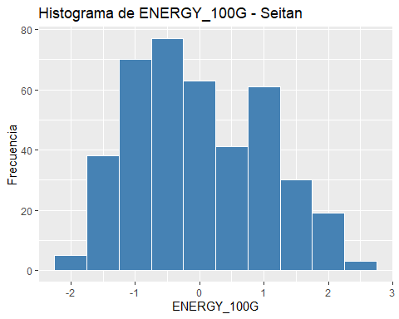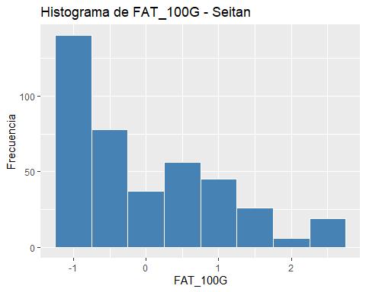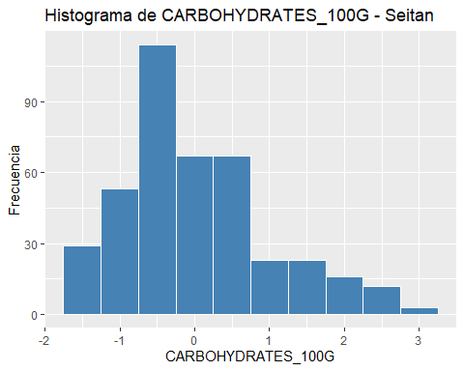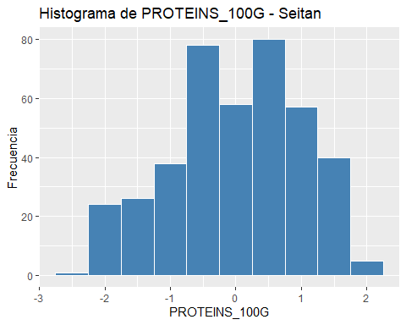

s_seitan <- scale(df_seitan[,-1:-2])  
  
# total de cluster óptimos  
elbow <- fviz_nbclust(x = s_seitan, FUNcluster = kmeans, method = "wss", k.max = 15,   
 diss = get_dist(s_seitan, method = "euclidean"), nstart = 25)  
print(elbow)

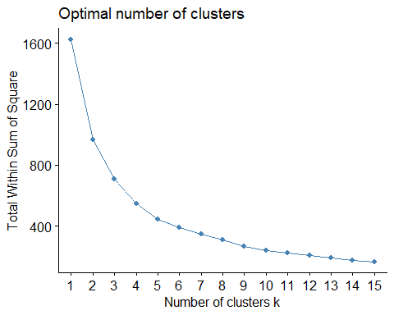

# set.seed(123)  
# km_clusters <- kmeans(x=s_seitan,centers=4,nstart=50)  
# fviz_cluster(object=km_clusters,data=s_seitan,show.clust.cent = TRUE,  
# ellipse.type="euclid",star.plot=TRUE,repel=TRUE,  
# pointsize=0.5,outlier.color="darkred") +  
# labs(title ="Resultados clustering K-means") +  
# theme_bw() +  
# theme(legend.position = "none")  
  
set.seed(123)  
km_clusters <- kmeans(x = s_seitan, centers = 4, nstart = 50)  
  
fviz_cluster(object = km_clusters, data = s_seitan, show.clust.cent = TRUE,  
 ellipse.type = "euclid", star.plot = TRUE, repel = TRUE,  
 pointsize = 0.5, outlier.color = "darkred", geom = "point") +  
 theme_bw() +  
 theme(legend.position = "none") +  
 ggtitle("Resultados clustering K-means Seitan")

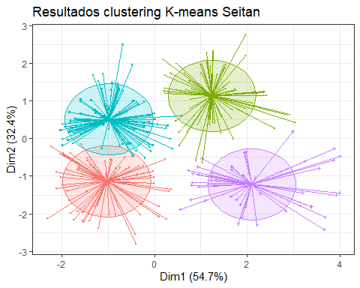

set.seed(101)  
  
hc_euclidea_av <- hclust(d = dist(x = s_seitan, method = "euclidean"),  
 method = "average")  
fviz_dend(x = hc_euclidea_av, k = 4, cex = 0.5,  
 k_colors = c("red","blue","green","magenta"),color_labels_by_k = T,  
 lwd = 0.2,type = "r",label_cols = rainbow(nrow(df_seitan)),  
 rect_lty = "lightblue") +  
 geom_hline(yintercept = 3.65, linetype = "dashed") +  
 labs(title = "Herarchical clustering Seitan",  
 subtitle = "Distancia euclidea, Average, k=4")

## Warning: The `<scale>` argument of `guides()` cannot be `FALSE`. Use "none" instead as  
## of ggplot2 3.3.4.  
## ℹ The deprecated feature was likely used in the factoextra package.  
## Please report the issue at <https://github.com/kassambara/factoextra/issues>.  
## This warning is displayed once every 8 hours.  
## Call `lifecycle::last_lifecycle_warnings()` to see where this warning was  
## generated.

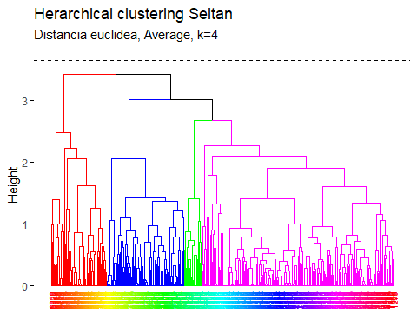

pam.res <- pam(s_seitan, 4)  
# Visualización  
fviz_cluster(pam.res, geom = "point", ellipse.type = "norm",  
 show.clust.cent = TRUE,star.plot = TRUE)+  
 labs(title = "Resultados clustering K-means superpuestos - Seitan")+ theme_bw()

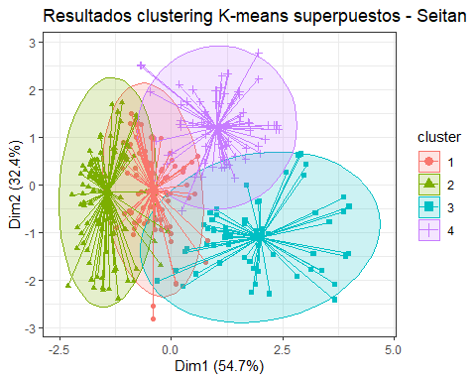

# Biplot PCA y K-Means para medir representatividad seitan

# PCA  
pca <- prcomp(df_seitan[,-1:-2], scale=TRUE)  
df_seitan.pca <- pca$x  
# Cluster over the three first PCA dimensions  
kc <- kmeans(df_seitan.pca[,1:3], 4)  
fviz_pca_biplot(pca, label="var", habillage=as.factor(kc$cluster)) +  
 labs(color=NULL) + ggtitle("") +  
 theme(text = element_text(size = 15),  
 panel.background = element_blank(),   
 panel.grid.major = element_blank(),  
 panel.grid.minor = element_blank(),  
 axis.line = element_line(colour = "black"),  
 legend.key = element_rect(fill = "white"))

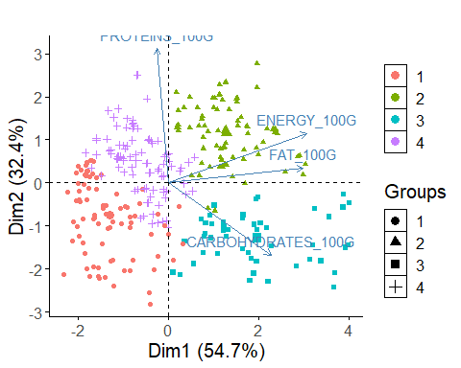

library(ggplot2)  
  
# Obtener los centroides de cada clúster  
centroids <- as.data.frame(km_clusters$centers)  
  
  
# Obtener el valor mínimo y máximo en el dataframe  
min_value <- min(centroids, na.rm = TRUE)  
max_value <- max(centroids, na.rm = TRUE)  
  
# Escalar los datos entre 0 y 1  
scaled_df <- (centroids - min_value) / (max_value - min_value)  
  
library(fmsb)

## Warning: package 'fmsb' was built under R version 4.3.1

# Define the variable ranges: maximum and minimum  
max_min <- data.frame(  
 ENERGY_100G = c(1, 0), FAT_100G = c(1, 0), CARBOHYDRATES_100G = c(1, 0),PROTEINS_100G = c(1, 0)  
)  
rownames(max_min) <- c("Max", "Min")  
  
# Bind the variable ranges to the data  
df <- rbind(max_min, scaled_df)

create_beautiful_radarchart <- function(data, color = "#00AFBB",   
 vlabels = colnames(data), vlcex = 0.7,  
 caxislabels = NULL, title = NULL, ...){  
 radarchart(  
 data, axistype = 1,  
 # Customize the polygon  
 pcol = color, pfcol = scales::alpha(color, 0.3), plwd = 2, plty = 1,  
 # Customize the grid  
 cglcol = "grey", cglty = 1, cglwd = 0.8,  
 # Customize the axis  
 axislabcol = "grey",   
 # Variable labels  
 vlcex = vlcex, vlabels = vlabels,  
 caxislabels = caxislabels, title = title, ...  
 )  
}

# Reduce plot margin using par()  
op <- par(mar = c(1, 2, 2, 1))  
create_beautiful_radarchart(df, caxislabels = c(0, .25, .5, .75, 1))

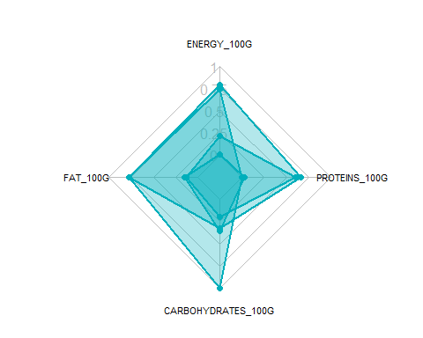

par(op)

# Reduce plot margin using par()  
op <- par(mar = c(1, 2, 2, 2))  
# Create the radar charts  
create_beautiful_radarchart(  
 data = df, caxislabels = c(0, .25, .5, .75, 1),  
 color = c("#00AFBB", "#E7B800", "#FC4E07","#7A378B")  
)  
# Add an horizontal legend  
legend(  
 x = "bottom", legend = rownames(df[-c(1,2),]), horiz = TRUE,  
 bty = "n", pch = 20 , col = c("#00AFBB", "#E7B800", "#FC4E07","#7A378B"),  
 text.col = "black", cex = 1, pt.cex = 1.5  
 )

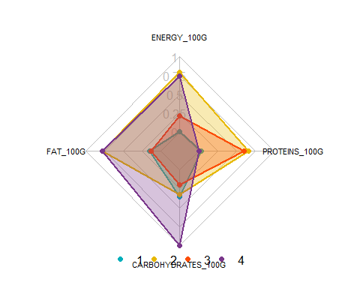

par(op)

# Define colors and titles  
colors <- c("#00AFBB", "#E7B800", "#FC4E07","blue")  
titles <- c("1", "2", "3","4")  
  
# Reduce plot margin using par()  
# Split the screen in 3 parts  
op <- par(mar = c(1, 1, 1, 1))  
  
par(mfrow = c(1,4))  
  
# Create the radar chart  
for(i in 1:4){  
 create_beautiful_radarchart(  
 data = df[c(1, 2, i+2), ], caxislabels = c(0, .25, .5, .75, 1),  
 color = colors[i], title = titles[i]  
 )  
}

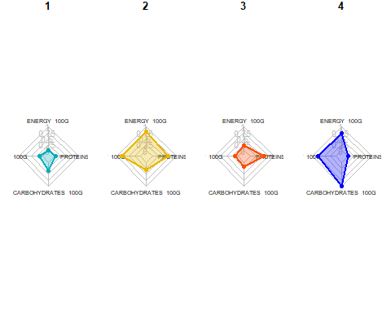

par(op)

# Visualizar los productos más cercanos al centroide que representan cada cluster top10

# Realizar clustering en el dataframe  
set.seed(123)  
df_top <- df_seitan  
km_clusters <- kmeans(x = df_top[, c("ENERGY_100G", "FAT_100G", "CARBOHYDRATES_100G", "PROTEINS_100G")], centers = 4, nstart = 50)  
  
# Obtener las asignaciones de clúster  
cluster_assignments <- km_clusters$cluster  
  
# Agregar las asignaciones de clúster al dataframe  
df_top$cluster <- cluster_assignments  
  
# Inicializar una lista para almacenar los productos más cercanos a cada centroide  
closest_products <- vector("list", max(cluster_assignments))  
  
# Encontrar los productos más cercanos a cada centroide  
for (cluster in 1:max(cluster_assignments)) {  
 cluster_center <- km_clusters$centers[cluster, ]  
 distances <- apply(df_top[, c("ENERGY_100G", "FAT_100G", "CARBOHYDRATES_100G", "PROTEINS_100G")], 1, function(row) {  
 sum((row - cluster_center)^2)  
 })  
 closest_products[[cluster]] <- head(order(distances), 10)  
}  
  
# Imprimir los productos más cercanos a cada centroide  
for (cluster in 1:max(cluster_assignments)) {  
 cat("Cluster", cluster, ":\n")  
 print(df_top[closest_products[[cluster]], c("PRODUCT_NAME", "ENERGY_100G", "FAT_100G", "CARBOHYDRATES_100G", "PROTEINS_100G")])  
 cat("\n")  
}

## Cluster 1 :  
## PRODUCT_NAME ENERGY_100G FAT_100G  
## 7673 CROCCHETTA DI SEITAN 649 2.0  
## 2116 ARROSTO DI SEITAN 653 1.4  
## 5972 SEITAN VEGGIE-HACHE 653 1.5  
## 5977 SEITAN MET MARROKAANSE KRUIDEN 653 1.5  
## 8523 BIO BURGUER VEGETAL SEITAN AL CURRY 649 6.9  
## 8538 BIO MAXI BURGUER VEGETAL, SEITAN AL CURRY 649 6.9  
## 5708 SEITANGEHAKT 636 0.9  
## 1538 SEITAN 636 1.0  
## 4363 SEITAN, DURCHSCHNITT 636 1.0  
## 6031 VEGAN BURGER SEITAN WITH CHEESE FLAVOR 657 5.0  
## CARBOHYDRATES_100G PROTEINS_100G  
## 7673 14.0 19  
## 2116 12.0 23  
## 5972 13.0 21  
## 5977 13.0 21  
## 8523 9.8 11  
## 8538 9.8 11  
## 5708 7.8 28  
## 1538 5.6 30  
## 4363 5.6 30  
## 6031 13.0 14  
##   
## Cluster 2 :  
## PRODUCT_NAME ENERGY_100G FAT_100G  
## 8547 SALCHIVEGGIE SEITAN Y TOFU 1071 12.0  
## 4784 BISTECCA DI SEITAN BIO ALLA MEDITERRANEA 1059 14.0  
## 7869 AFFETTATO VEGETALE DI SEITAN E TOFU 1075 14.7  
## 7864 AFFETTATO VEGETALE DI SEITAN E TOFU 1075 15.0  
## 1976 SEITAN TOFU 1079 14.8  
## 8535 BIO SEITAN Y TOFU TRADICIONAL 1084 15.0  
## 8385 SEITAN CON TOFU 1086 15.0  
## 8536 SEITAN Y TOFU TRADICIONAL 1088 15.0  
## 8795 SEITAN BIO 1088 15.0  
## 7651 CHARCUTERIE DE SEITAN 1042 12.0  
## CARBOHYDRATES_100G PROTEINS_100G  
## 8547 10.0 26.0  
## 4784 11.0 19.0  
## 7869 7.5 23.0  
## 7864 7.6 23.0  
## 1976 6.8 23.1  
## 8535 6.8 23.0  
## 8385 6.9 23.0  
## 8536 6.8 23.0  
## 8795 6.8 23.0  
## 7651 9.9 24.0  
##   
## Cluster 3 :  
## PRODUCT_NAME ENERGY_100G FAT_100G CARBOHYDRATES_100G  
## 8787 SEITAN NATURAL VEGANO 444 1.00 4.200000  
## 792 CUBED SEITAN WHEAT PROTEIN 443 0.00 4.705882  
## 7870 SEITAN INCREDIBILE 448 1.10 8.300000  
## 7515 SEITAN BIOLOGICO AL NATURALE 448 1.10 8.300000  
## 453 SEITAN 448 0.77 9.520000  
## 6033 SEITAN NATURAL 452 1.30 1.900000  
## 2239 SEITAN GOURMET 456 1.50 6.000000  
## 2235 SEITAN GOUTMET 456 1.50 6.000000  
## 2236 SEITAN GOURMET ORIGINAL 456 1.50 6.000000  
## 2241 SEITAN GOURMET 456 1.50 6.000000  
## PROTEINS_100G  
## 8787 20.00000  
## 792 21.17647  
## 7870 16.00000  
## 7515 16.00000  
## 453 17.86000  
## 6033 21.50000  
## 2239 17.50000  
## 2235 18.00000  
## 2236 18.00000  
## 2241 18.00000  
##   
## Cluster 4 :  
## PRODUCT_NAME ENERGY_100G FAT_100G CARBOHYDRATES_100G  
## 2164 SEITAN ALLA PIASTRA 879 7.7000 11.7000  
## 1493 SEITAN 865 8.6667 10.0000  
## 4913 SEITAN AUFSCHNITT SPICY BEANS 864 6.8000 9.3000  
## 2183 COTOLETTA DI SEITAN DORATA 879 4.0000 17.0000  
## 4458 SEITAN 883 9.4000 8.6000  
## 4910 SEITAN GESCHNETZELTES 883 6.8000 8.0000  
## 4921 SEITAN HACK 883 6.8000 8.0000  
## 4456 MEDAILLONS DE SEITAN 866 6.6000 4.1000  
## 1494 SEITAN VEGE-POULET 886 8.2353 10.5882  
## 4908 SEITAN GERAUCHERT 862 7.1000 5.0000  
## PROTEINS_100G  
## 2164 23.3000  
## 1493 22.0000  
## 4913 25.2000  
## 2183 18.0000  
## 4458 22.4000  
## 4910 28.0000  
## 4921 28.0000  
## 4456 31.4000  
## 1494 23.5294  
## 4908 29.3000

##### TOfu

# Aplicar algoritmo Local Outliers Factor para eliminar atípicos  
  
# 1.- First, we need to convert the incorrect type of variables.  
  
tofu_clean <- df_tofu %>%  
 mutate(PRODUCT_NAME = as.factor(PRODUCT_NAME))  
str(tofu_clean)

## 'data.frame': 2573 obs. of 6 variables:  
## $ ISO3 : chr "FRA" "USA" "USA" "USA" ...  
## $ PRODUCT_NAME : Factor w/ 1777 levels "1KG TOFU NATURE",..: 644 1444 1327 1310 1259 656 1464 902 36 38 ...  
## $ ENERGY_100G : num 2686 540 644 372 1339 ...  
## $ FAT_100G : num 62.7 7.09 9 3.8 28 ...  
## $ CARBOHYDRATES_100G: num 12.2 0 2.1 2.53 6 ...  
## $ PROTEINS_100G : num 6.3 13.73 16 8.86 18 ...

tofu_clean <- as.data.frame(scale(df_tofu[,-1:-2]))  
tofu_lof <- lof(tofu_clean, minPts = 7)  
head(tofu_clean)

## ENERGY_100G FAT_100G CARBOHYDRATES_100G PROTEINS_100G  
## 1 4.8699152 7.94578098 0.52089238 -1.0053709  
## 4 -0.3527459 -0.30503960 -0.68672534 0.2701272  
## 5 -0.0996440 -0.02165413 -0.47885671 0.6598151  
## 6 -0.7616029 -0.79317485 -0.43629314 -0.5658991  
## 21 1.5917584 2.79736388 -0.09281498 1.0031524  
## 25 -0.9392610 -0.82709208 -0.45104191 -0.8606714

#PCA and use the first two dimensions of the PCA  
library(FactoMineR)  
library(factoextra)  
  
tofu_pca <- PCA(tofu_clean, scale.unit = F, ncp = 6, graph = F)

summary(tofu_pca)

##   
## Call:  
## PCA(X = tofu_clean, scale.unit = F, ncp = 6, graph = F)   
##   
##   
## Eigenvalues  
## Dim.1 Dim.2 Dim.3 Dim.4  
## Variance 2.005 1.089 0.695 0.210  
## % of var. 50.133 27.246 17.378 5.243  
## Cumulative % of var. 50.133 77.380 94.757 100.000  
##   
## Individuals (the 10 first)  
## Dist Dim.1 ctr cos2 Dim.2 ctr cos2   
## 1 | 9.388 | 7.585 1.116 0.653 | 0.326 0.004 0.001 |  
## 4 | 0.873 | -0.535 0.006 0.375 | -0.679 0.016 0.606 |  
## 5 | 0.822 | 0.003 0.000 0.000 | -0.784 0.022 0.910 |  
## 6 | 1.311 | -1.303 0.033 0.988 | 0.068 0.000 0.003 |  
## 21 | 3.373 | 2.986 0.173 0.784 | -0.958 0.033 0.081 |  
## 25 | 1.584 | -1.550 0.047 0.958 | 0.231 0.002 0.021 |  
## 31 | 2.449 | -0.268 0.001 0.012 | 2.384 0.203 0.948 |  
## 32 | 2.066 | -1.969 0.075 0.908 | 0.494 0.009 0.057 |  
## 33 | 0.888 | 0.463 0.004 0.272 | -0.436 0.007 0.241 |  
## 34 | 0.519 | -0.232 0.001 0.200 | -0.256 0.002 0.243 |  
## Dim.3 ctr cos2   
## 1 -5.494 1.688 0.342 |  
## 4 0.081 0.000 0.009 |  
## 5 0.245 0.003 0.089 |  
## 6 -0.047 0.000 0.001 |  
## 21 -1.151 0.074 0.117 |  
## 25 -0.220 0.003 0.019 |  
## 31 0.483 0.013 0.039 |  
## 32 -0.377 0.008 0.033 |  
## 33 0.615 0.021 0.480 |  
## 34 0.385 0.008 0.550 |  
##   
## Variables  
## Dim.1 ctr cos2 Dim.2 ctr cos2 Dim.3  
## ENERGY_100G | 0.934 43.535 0.873 | 0.097 0.859 0.009 | -0.038  
## FAT_100G | 0.813 32.980 0.661 | -0.151 2.102 0.023 | -0.507  
## CARBOHYDRATES_100G | 0.461 10.610 0.213 | 0.793 57.650 0.628 | 0.364  
## PROTEINS_100G | 0.508 12.875 0.258 | -0.655 39.389 0.429 | 0.551  
## ctr cos2   
## ENERGY_100G 0.209 0.001 |  
## FAT_100G 36.999 0.257 |  
## CARBOHYDRATES_100G 19.030 0.132 |  
## PROTEINS_100G 43.763 0.304 |

fviz_eig(tofu_pca, ncp = 6, addlabels = T, main = "Variance explained by each dimensions TOfu")

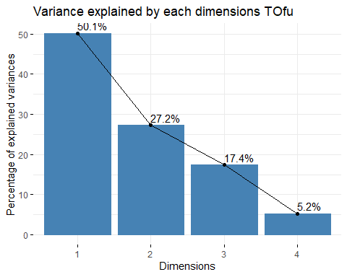

library(ggthemes)  
tofu_a <- data.frame(tofu_pca$ind$coord[,1:3])  
tofu_b <- cbind(tofu_a, lof_score = tofu_lof)  
#tofu_b <- cbind(tofu_a, fraud = tofu_clean$, lof_score = tofu_clean$lof)  
  
tofu_lof_visual <- ggplot(tofu_b, aes(x=Dim.1 ,y=Dim.2)) +   
 geom_point(aes(size=lof_score)) +  
 ggtitle("LOF Score Distribution Tofu")+  
 theme_minimal()  
  
tofu_lof_visual

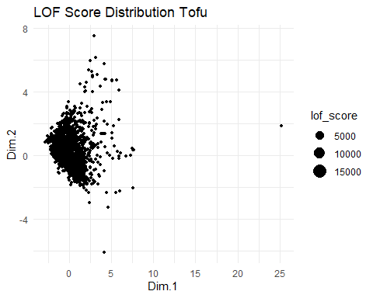

summary(tofu_b)

## Dim.1 Dim.2 Dim.3 lof_score   
## Min. :-2.8010 Min. :-6.1192 Min. :-6.70705 Min. :0.891   
## 1st Qu.:-0.8268 1st Qu.:-0.6815 1st Qu.:-0.25831 1st Qu.:1.000   
## Median :-0.1894 Median :-0.2541 Median : 0.02004 Median :1.051   
## Mean : 0.0000 Mean : 0.0000 Mean : 0.00000 Mean : Inf   
## 3rd Qu.: 0.6327 3rd Qu.: 0.4513 3rd Qu.: 0.29919 3rd Qu.:1.210   
## Max. :25.2285 Max. : 7.5074 Max. : 6.30615 Max. : Inf

tofu_b %>%  
 filter(lof_score <= 1.75) %>%   
 ggplot( aes(x=lof_score)) +  
 geom_density( color="#e9ecef", fill = "#c90076", alpha=0.7) +  
 scale_fill_manual(values="#8fce00") +  
 xlab("LOF Score")+  
 ggtitle("LOF Score Distribution Tofu")+  
 theme_minimal() +  
 labs(fill="")

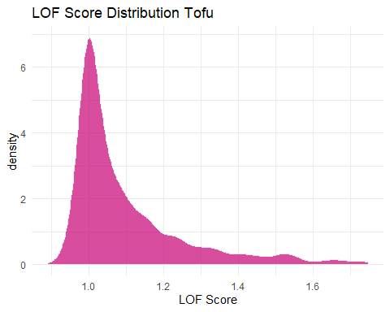

quantile(tofu_b$lof_score, probs = c(0, 0.8))

## 0% 80%   
## 0.8909538 1.2822731

tofu_b <- tofu_b %>%   
 mutate(outlier = ifelse(lof_score > 1.2822731, 1, 0))  
  
tofu_lof_visual_b <- ggplot(tofu_b, aes(x=Dim.1 ,y=Dim.2, color=outlier)) +   
 geom_point() +  
 ggtitle("LOF Score Distribution Tofu")+  
 theme_minimal()  
  
tofu_lof_visual_b

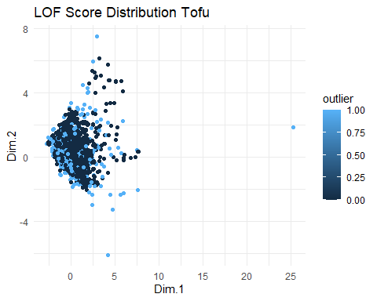

outliers <- tofu_b[tofu_b$outlier==1,]  
nooutliers <- tofu_b[tofu_b$outlier==0,]

df_tofu <- df_tofu[tofu_lof < 1.2822731,]  
df_tofu_outliers <- df_tofu[tofu_lof >= 1.2822731,]

# Eliminar valores atipicos univariantes

remove_outliers <- function(data, column, sd_threshold = 2) {  
 data[abs(scale(data[[column]])) < sd_threshold, ]  
}  
  
columns_to_check <- 3:ncol(df_tofu)  
for (column in columns_to_check) {  
 df_tofu <- remove_outliers(df_tofu, column)  
}

# Obtener las columnas cuantitativas del dataframe  
columnas_cuantitativas <- sapply(df_tofu, is.numeric)  
  
# Crear un histograma para cada columna cuantitativa  
for (columna in names(df_tofu[columnas_cuantitativas])) {  
 plot_data <- df_tofu[, columna]  
 p <- ggplot(data.frame(x = plot_data), aes(x)) +  
 geom_histogram(binwidth = 0.5, fill = "steelblue", color = "white") +  
 labs(title = paste("Histograma de", columna,"- Tofu"),  
 x = columna,  
 y = "Frecuencia")  
   
 print(p)  
}

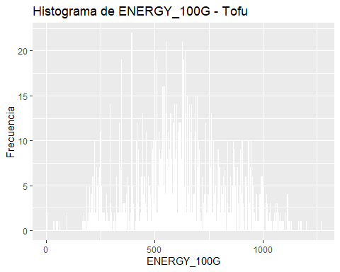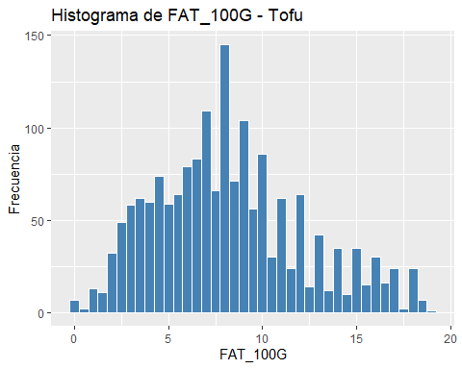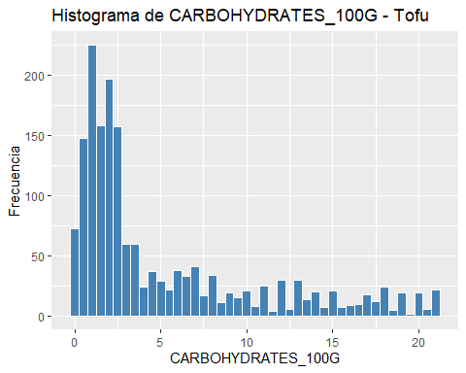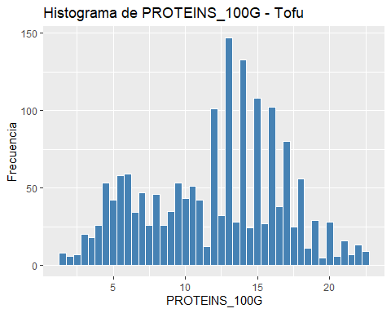

summary(as.data.frame(scale(df_tofu[,-1:-2])))

## ENERGY_100G FAT_100G CARBOHYDRATES_100G PROTEINS_100G   
## Min. :-2.73776 Min. :-2.06845 Min. :-0.9238 Min. :-2.1740   
## 1st Qu.:-0.67147 1st Qu.:-0.73635 1st Qu.:-0.7083 1st Qu.:-0.7927   
## Median :-0.04752 Median :-0.08065 Median :-0.5013 Median : 0.2115   
## Mean : 0.00000 Mean : 0.00000 Mean : 0.0000 Mean : 0.0000   
## 3rd Qu.: 0.68495 3rd Qu.: 0.59620 3rd Qu.: 0.3873 3rd Qu.: 0.7594   
## Max. : 2.99539 Max. : 2.66201 Max. : 2.8766 Max. : 2.2135

#Datos normalizados para el tofu

s_tofu <- as.data.frame(scale(df_tofu[,-1:-2]))  
# Obtener las columnas cuantitativas del dataframe  
columnas_cuantitativas <- sapply(s_tofu, is.numeric)  
  
# Crear un histograma para cada columna cuantitativa  
for (columna in names(s_tofu[columnas_cuantitativas])) {  
 plot_data <- s_tofu[, columna]  
 p <- ggplot(data.frame(x = plot_data), aes(x)) +  
 geom_histogram(binwidth = 0.5, fill = "steelblue", color = "white") +  
 labs(title = paste("Histograma de", columna,"para el Tofu"),  
 x = columna,  
 y = "Frecuencia")  
   
 print(p)  
}

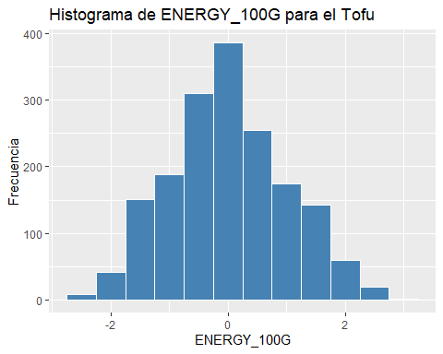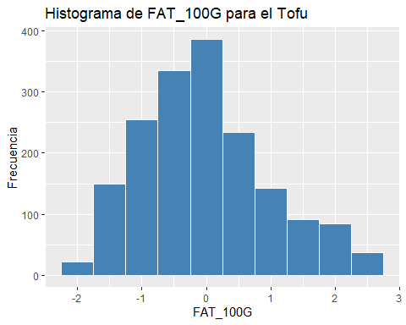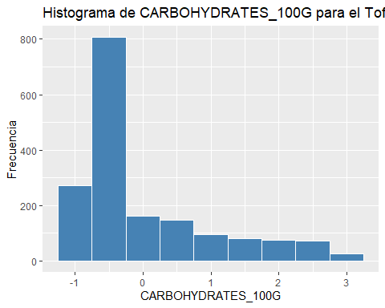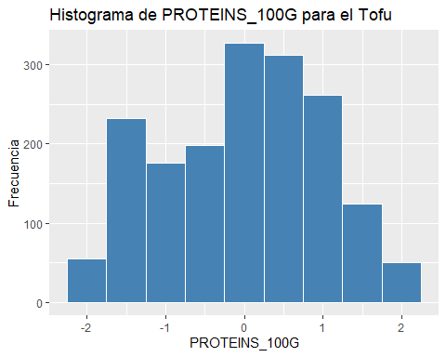

s_tofu <- scale(df_tofu[,-1:-2])  
  
# total de cluster óptimos  
elbow <- fviz_nbclust(x = s_tofu, FUNcluster = kmeans, method = "wss", k.max = 15,   
 diss = get_dist(s_tofu, method = "euclidean"), nstart = 25)  
print(elbow)

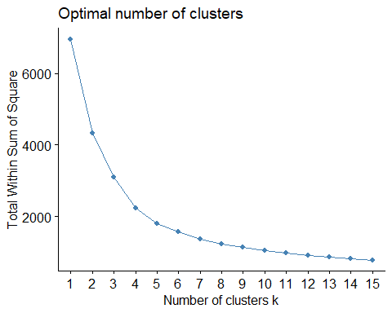

# set.seed(123)  
# km_clusters <- kmeans(x=s_tofu,centers=4,nstart=25)  
# fviz_cluster(object=km_clusters,data=s_tofu,show.clust.cent = TRUE,  
# ellipse.type="euclid",star.plot=TRUE,repel=TRUE,  
# pointsize=0.5,outlier.color="darkred") +  
# labs(title ="Resultados clustering K-means") +  
# theme_bw() +  
# theme(legend.position = "none")  
  
set.seed(123)  
km_clusters <- kmeans(x = s_tofu, centers = 4, nstart = 25)  
  
fviz_cluster(object = km_clusters, data = s_tofu, show.clust.cent = TRUE,  
 ellipse.type = "euclid", star.plot = TRUE, repel = TRUE,  
 pointsize = 0.5, outlier.color = "darkred", geom = "point") +  
 theme_bw() +  
 theme(legend.position = "none") +  
 ggtitle("Resultados clustering K-means Tofu")

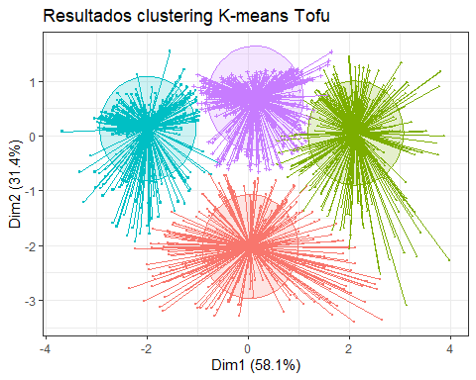

set.seed(101)  
hc_euclidea_av <- hclust(d = dist(x = s_tofu, method = "euclidean"),  
 method = "average")  
fviz_dend(x = hc_euclidea_av, k = 4, cex = 0.5,  
 k_colors = c("red","blue","green","magenta"),color_labels_by_k = T,  
 lwd = 0.2,type = "r",label_cols = rainbow(nrow(df_tofu)),  
 rect_lty = "lightblue") +  
 geom_hline(yintercept = 3.65, linetype = "dashed") +  
 labs(title = "Herarchical clustering Tofu",  
 subtitle = "Distancia euclidea, Average, k=4")

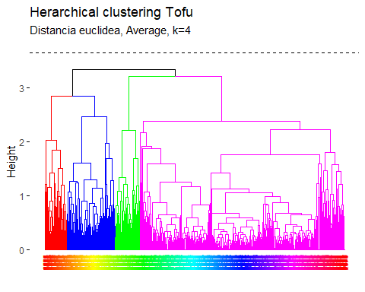

pam.res <- pam(s_tofu, 4)  
# Visualización  
fviz_cluster(pam.res, geom = "point", ellipse.type = "norm",  
 show.clust.cent = TRUE,star.plot = TRUE)+  
 labs(title = "Resultados clustering K-means Superpuestos Tofu")+ theme_bw()

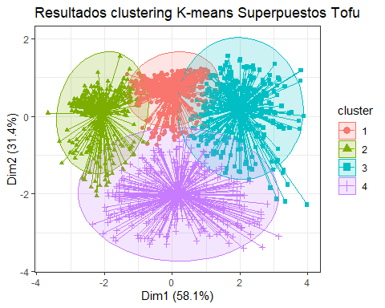 # Biplot PCA y K-Means para medir representatividad tofu

# PCA  
pca <- prcomp(df_tofu[,-1:-2], scale=TRUE)  
df_tofu.pca <- pca$x  
# Cluster over the three first PCA dimensions  
kc <- kmeans(df_tofu.pca[,1:3], 4)  
fviz_pca_biplot(pca, label="var", habillage=as.factor(kc$cluster)) +  
 labs(color=NULL) + ggtitle("") +  
 theme(text = element_text(size = 15),  
 panel.background = element_blank(),   
 panel.grid.major = element_blank(),  
 panel.grid.minor = element_blank(),  
 axis.line = element_line(colour = "black"),  
 legend.key = element_rect(fill = "white"))

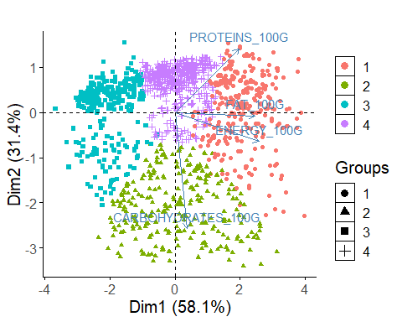

library(ggplot2)  
  
# Obtener los centroides de cada clúster  
centroids <- as.data.frame(km_clusters$centers)  
  
  
# Obtener el valor mínimo y máximo en el dataframe  
min_value <- min(centroids, na.rm = TRUE)  
max_value <- max(centroids, na.rm = TRUE)  
  
# Escalar los datos entre 0 y 1  
scaled_df <- (centroids - min_value) / (max_value - min_value)  
  
library(fmsb)  
  
  
# Define the variable ranges: maximum and minimum  
max_min <- data.frame(  
 ENERGY_100G = c(1, 0), FAT_100G = c(1, 0), CARBOHYDRATES_100G = c(1, 0),PROTEINS_100G = c(1, 0)  
)  
rownames(max_min) <- c("Max", "Min")  
  
# Bind the variable ranges to the data  
df <- rbind(max_min, scaled_df)

create_beautiful_radarchart <- function(data, color = "#00AFBB",   
 vlabels = colnames(data), vlcex = 0.7,  
 caxislabels = NULL, title = NULL, ...){  
 radarchart(  
 data, axistype = 1,  
 # Customize the polygon  
 pcol = color, pfcol = scales::alpha(color, 0.3), plwd = 2, plty = 1,  
 # Customize the grid  
 cglcol = "grey", cglty = 1, cglwd = 0.8,  
 # Customize the axis  
 axislabcol = "grey",   
 # Variable labels  
 vlcex = vlcex, vlabels = vlabels,  
 caxislabels = caxislabels, title = title, ...  
 )  
}

# Reduce plot margin using par()  
op <- par(mar = c(1, 2, 2, 1))  
create_beautiful_radarchart(df, caxislabels = c(0, .25, .5, .75, 1))

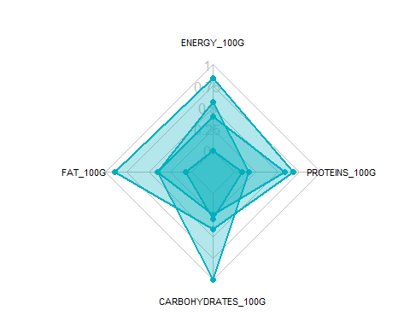

par(op)

# Reduce plot margin using par()  
op <- par(mar = c(1, 2, 2, 2))  
# Create the radar charts  
create_beautiful_radarchart(  
 data = df, caxislabels = c(0, .25, .5, .75, 1),  
 color = c("#00AFBB", "#E7B800", "#FC4E07","#7A378B")  
)  
# Add an horizontal legend  
legend(  
 x = "bottom", legend = rownames(df[-c(1,2),]), horiz = TRUE,  
 bty = "n", pch = 20 , col = c("#00AFBB", "#E7B800", "#FC4E07","#7A378B"),  
 text.col = "black", cex = 1, pt.cex = 1.5  
 )

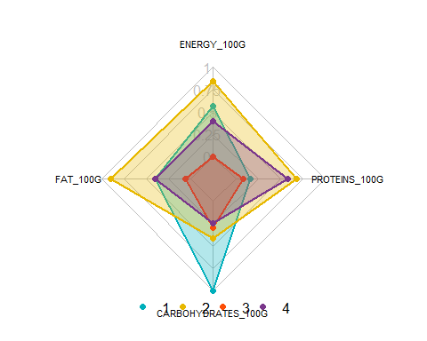

par(op)

# Define colors and titles  
colors <- c("#00AFBB", "#E7B800", "#FC4E07","blue")  
titles <- c("1", "2", "3","4")  
  
# Reduce plot margin using par()  
# Split the screen in 3 parts  
op <- par(mar = c(1, 1, 1, 1))  
  
par(mfrow = c(1,4))  
  
# Create the radar chart  
for(i in 1:4){  
 create_beautiful_radarchart(  
 data = df[c(1, 2, i+2), ], caxislabels = c(0, .25, .5, .75, 1),  
 color = colors[i], title = titles[i]  
 )  
}

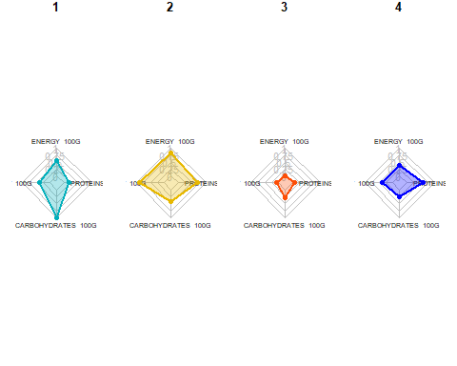

par(op)

# Visualizar los productos más cercanos al centroide que representan cada cluster top10

# Realizar clustering en el dataframe  
set.seed(123)  
df_top <- df_tofu  
km_clusters <- kmeans(x = df_top[, c("ENERGY_100G", "FAT_100G", "CARBOHYDRATES_100G", "PROTEINS_100G")], centers = 4, nstart = 50)  
  
# Obtener las asignaciones de clúster  
cluster_assignments <- km_clusters$cluster  
  
# Agregar las asignaciones de clúster al dataframe  
df_top$cluster <- cluster_assignments  
  
# Inicializar una lista para almacenar los productos más cercanos a cada centroide  
closest_products <- vector("list", max(cluster_assignments))  
  
# Encontrar los productos más cercanos a cada centroide  
for (cluster in 1:max(cluster_assignments)) {  
 cluster_center <- km_clusters$centers[cluster, ]  
 distances <- apply(df_top[, c("ENERGY_100G", "FAT_100G", "CARBOHYDRATES_100G", "PROTEINS_100G")], 1, function(row) {  
 sum((row - cluster_center)^2)  
 })  
 closest_products[[cluster]] <- head(order(distances), 10)  
}  
  
# Imprimir los productos más cercanos a cada centroide  
for (cluster in 1:max(cluster_assignments)) {  
 cat("Cluster", cluster, ":\n")  
 print(df_top[closest_products[[cluster]], c("PRODUCT_NAME", "ENERGY_100G", "FAT_100G", "CARBOHYDRATES_100G", "PROTEINS_100G")])  
 cat("\n")  
}

## Cluster 1 :  
## PRODUCT_NAME ENERGY_100G FAT_100G CARBOHYDRATES_100G  
## 4407 NIGARI TOFU 701 11.50 8.50  
## 1800 TOFU YU, TERIYAKI TOFU SUSHI 703 10.18 7.96  
## 4447 ALGEN RAUCHER-TOFU 697 10.80 1.50  
## 7888 DRY TOFU 695 9.30 4.40  
## 7923 TOFU SECO 695 9.30 4.40  
## 2362 TOFU MARINOVANE 695 9.90 3.50  
## 2402 TOFU 703 11.40 1.10  
## 2403 TOFU BIO SOYANA 703 11.40 1.10  
## 6170 TOFU WĘDZONE 695 10.80 2.60  
## 9328 TOFU AROMATIZZATO 699 8.65 11.12  
## PROTEINS_100G  
## 4407 12.20  
## 1800 15.49  
## 4447 14.90  
## 7888 16.00  
## 7923 16.00  
## 2362 16.00  
## 2402 15.20  
## 2403 15.20  
## 6170 14.70  
## 9328 11.38  
##   
## Cluster 2 :  
## PRODUCT_NAME ENERGY_100G FAT_100G  
## 4793 TOFU-BURGER-STAR 941 15.00  
## 5032 TOFU-SEITAN TALER PANIERT 941 12.00  
## 7571 COTOLETTA DI TOFU E SEITAN 946 11.79  
## 7562 COTOLETTA DI TOFU E SEITAN 946 11.70  
## 5922 TOFUREEPJES LICHT GEKRUID (6) 941 15.50  
## 7863 FETTADELICATA TOFU E PEPERONI GRIGLIATI 937 14.40  
## 5923 LAMELLES DE TOFU ORIENTALES 937 15.20  
## 5446 FISH TOFU 946 15.40  
## 4328 FILETES DE TOFU CON OREGANO 944 15.50  
## 8838 TOFU SAUSAGES 941 18.00  
## CARBOHYDRATES_100G PROTEINS_100G  
## 4793 7.0 15.0  
## 5032 11.0 16.0  
## 7571 10.8 15.6  
## 7562 10.8 15.6  
## 5922 2.9 17.6  
## 7863 4.4 17.5  
## 5923 3.6 17.2  
## 5446 11.2 10.6  
## 4328 2.8 18.5  
## 8838 2.7 12.0  
##   
## Cluster 3 :  
## PRODUCT_NAME ENERGY_100G FAT_100G CARBOHYDRATES_100G  
## 8662 TOFU CON SEMILLA DE AMAPOLA 527 6.8 3.3  
## 4503 TOFU VEMONDO 523 7.5 2.3  
## 4504 TOFU BASIL 523 7.5 2.3  
## 6165 TOFU NATURALNE 523 7.5 2.3  
## 8815 TOFU (ORIGINAL) 523 7.5 2.3  
## 3475 TOFU NATURE 524 5.9 2.9  
## 2039 TOFU 521 7.5 2.3  
## 4497 TOFU NATURALNE 521 7.5 2.3  
## 4500 TOFU BASIL 521 7.5 2.3  
## 8399 ORGANIC TOFU JAPONES 527 8.0 0.7  
## PROTEINS_100G  
## 8662 12.20  
## 4503 12.00  
## 4504 12.00  
## 6165 12.00  
## 8815 12.00  
## 3475 15.00  
## 2039 12.00  
## 4497 12.00  
## 4500 12.00  
## 8399 12.26  
##   
## Cluster 4 :  
## PRODUCT_NAME ENERGY_100G FAT_100G CARBOHYDRATES_100G  
## 355 ORGANIC FIRM TOFU 293 3.500000 2.000000  
## 341 GREENWISE ORGANIC FIRM TOFU 293 4.000000 2.000000  
## 5412 TOFU 293 4.000000 0.900000  
## 385 MEDIUM FIRM TOFU 295 3.529412 2.352941  
## 723 TOFU 295 3.529412 2.352941  
## 730 HOUSE FOODS TOFU REGULAR 295 3.529412 2.352941  
## 735 TOFU 295 3.529412 2.352941  
## 749 TOFU MEDIUM FIRM 295 3.529412 2.352941  
## 1429 ORGANIC SILKEN TOFU 295 3.529412 2.352941  
## 1432 PULMUONE TOFU 295 3.529412 2.352941  
## PROTEINS_100G  
## 355 8.000000  
## 341 8.000000  
## 5412 7.200000  
## 385 7.058824  
## 723 7.058824  
## 730 7.058824  
## 735 7.058824  
## 749 7.058824  
## 1429 7.058824  
## 1432 7.058824

#### SOja

# Aplicar algoritmo Local Outliers Factor para eliminar atípicos  
  
# 1.- First, we need to convert the incorrect type of variables.  
  
soja_clean <- df_soja %>%  
 mutate(PRODUCT_NAME = as.factor(PRODUCT_NAME))  
str(soja_clean)

## 'data.frame': 2307 obs. of 6 variables:  
## $ ISO3 : chr "DEU" "FRA" "FRA" "FRA" ...  
## $ PRODUCT_NAME : Factor w/ 1786 levels "100% SOJA PROTEIN HASELNUSS",..: 1 972 1088 378 377 816 370 633 509 2 ...  
## $ ENERGY_100G : num 1590 1506 238 992 992 ...  
## $ FAT_100G : num 0.5 1.3 2.2 11 11 7.2 12 11 12 0.5 ...  
## $ CARBOHYDRATES_100G: num 1.1 6.1 5 18 18 10 16 18 34 1.1 ...  
## $ PROTEINS_100G : num 88.5 80 4.1 14 14 8.3 16 14 30 88.5 ...

soja_clean <- as.data.frame(scale(df_soja[,-1:-2]))  
soja_lof <- lof(soja_clean, minPts = 7)  
head(soja_clean)

## ENERGY_100G FAT_100G CARBOHYDRATES_100G PROTEINS_100G  
## 3 0.9762300 -0.6426124 -0.6911936 4.1291069  
## 7 0.8570027 -0.5813447 -0.4482222 3.6465293  
## 14 -0.9427609 -0.5124185 -0.5016759 -0.6626048  
## 15 0.1274455 0.1615261 0.1300499 -0.1005438  
## 16 0.1274455 0.1615261 0.1300499 -0.1005438  
## 17 -0.4076577 -0.1294955 -0.2587044 -0.4241547

#PCA and use the first two dimensions of the PCA  
library(FactoMineR)  
library(factoextra)  
  
soja_pca <- PCA(soja_clean, scale.unit = F, ncp = 6, graph = F)

summary(soja_pca)

##   
## Call:  
## PCA(X = soja_clean, scale.unit = F, ncp = 6, graph = F)   
##   
##   
## Eigenvalues  
## Dim.1 Dim.2 Dim.3 Dim.4  
## Variance 1.840 1.065 0.937 0.156  
## % of var. 46.016 26.636 23.436 3.912  
## Cumulative % of var. 46.016 72.652 96.088 100.000  
##   
## Individuals (the 10 first)  
## Dist Dim.1 ctr cos2 Dim.2 ctr cos2   
## 3 | 4.347 | 1.752 0.072 0.162 | 2.378 0.230 0.299 |  
## 7 | 3.817 | 1.587 0.059 0.173 | 2.186 0.195 0.328 |  
## 14 | 1.357 | -1.338 0.042 0.971 | -0.228 0.002 0.028 |  
## 15 | 0.263 | 0.173 0.001 0.431 | -0.108 0.000 0.169 |  
## 16 | 0.263 | 0.173 0.001 0.431 | -0.108 0.000 0.169 |  
## 17 | 0.656 | -0.599 0.008 0.834 | -0.258 0.003 0.154 |  
## 18 | 0.304 | 0.266 0.002 0.766 | -0.145 0.001 0.228 |  
## 19 | 0.263 | 0.173 0.001 0.431 | -0.108 0.000 0.169 |  
## 20 | 1.487 | 0.135 0.000 0.008 | 0.750 0.023 0.254 |  
## 23 | 4.347 | 1.752 0.072 0.162 | 2.378 0.230 0.299 |  
## Dim.3 ctr cos2   
## 3 -3.170 0.465 0.532 |  
## 7 -2.673 0.331 0.491 |  
## 14 0.031 0.000 0.001 |  
## 15 0.166 0.001 0.399 |  
## 16 0.166 0.001 0.399 |  
## 17 0.070 0.000 0.011 |  
## 18 0.021 0.000 0.005 |  
## 19 0.166 0.001 0.399 |  
## 20 0.225 0.002 0.023 |  
## 23 -3.170 0.465 0.532 |  
##   
## Variables  
## Dim.1 ctr cos2 Dim.2 ctr cos2 Dim.3  
## ENERGY_100G | 0.959 49.996 0.920 | -0.036 0.123 0.001 | -0.022  
## FAT_100G | 0.680 25.167 0.463 | -0.701 46.091 0.491 | 0.029  
## CARBOHYDRATES_100G | 0.425 9.817 0.181 | 0.491 22.640 0.241 | 0.753  
## PROTEINS_100G | 0.526 15.020 0.276 | 0.576 31.146 0.332 | -0.607  
## ctr cos2   
## ENERGY_100G 0.050 0.000 |  
## FAT_100G 0.093 0.001 |  
## CARBOHYDRATES_100G 60.489 0.567 |  
## PROTEINS_100G 39.369 0.369 |

fviz_eig(soja_pca, ncp = 6, addlabels = T, main = "Variance explained by each dimensions - Soja")

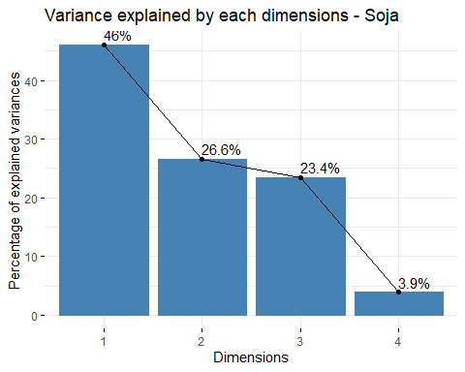

library(ggthemes)  
soja_a <- data.frame(soja_pca$ind$coord[,1:3])  
soja_b <- cbind(soja_a, lof_score = soja_lof)  
#soja_b <- cbind(soja_a, fraud = soja_clean$, lof_score = soja_clean$lof)  
  
soja_lof_visual <- ggplot(soja_b, aes(x=Dim.1 ,y=Dim.2)) +   
 geom_point(aes(size=lof_score)) +  
 ggtitle("LOF Score Distribution - Soja")+  
 theme_minimal()  
  
soja_lof_visual

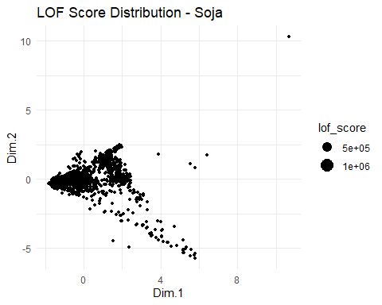

summary(soja_b)

## Dim.1 Dim.2 Dim.3 lof_score   
## Min. :-1.819 Min. :-5.7336 Min. :-3.356249 Min. :0.8486   
## 1st Qu.:-1.155 1st Qu.:-0.2986 1st Qu.:-0.399748 1st Qu.:1.0023   
## Median :-0.324 Median :-0.1251 Median :-0.003406 Median :1.0894   
## Mean : 0.000 Mean : 0.0000 Mean : 0.000000 Mean : Inf   
## 3rd Qu.: 1.106 3rd Qu.: 0.2907 3rd Qu.: 0.285728 3rd Qu.:1.3397   
## Max. :10.664 Max. :10.3010 Max. :21.178818 Max. : Inf

soja_b %>%  
 filter(lof_score <= 1.75) %>%   
 ggplot( aes(x=lof_score)) +  
 geom_density( color="#e9ecef", fill = "#c90076", alpha=0.7) +  
 scale_fill_manual(values="#8fce00") +  
 xlab("LOF Score")+  
 ggtitle("LOF Score Distribution - Soja")+  
 theme_minimal() +  
 labs(fill="")

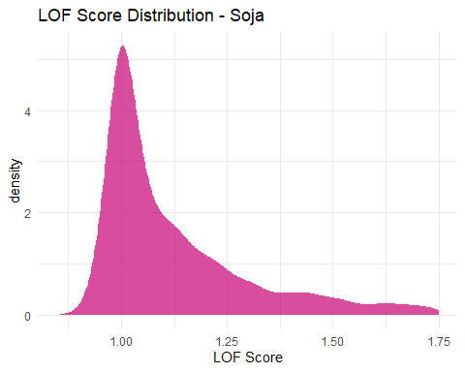

quantile(soja_b$lof_score, probs = c(0, 0.8))

## 0% 80%   
## 0.8485955 1.4686290

soja_b <- soja_b %>%   
 mutate(outlier = ifelse(lof_score > 1.4686290, 1, 0))  
  
soja_lof_visual_b <- ggplot(soja_b, aes(x=Dim.1 ,y=Dim.2, color=outlier)) +   
 geom_point() +  
 ggtitle("LOF Score Distribution - Soja")+  
 theme_minimal()  
  
soja_lof_visual_b

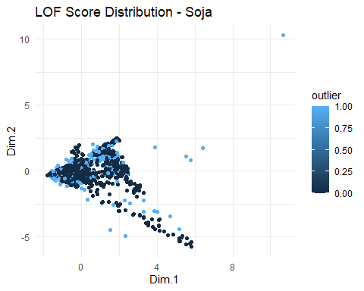

outliers <- soja_b[soja_b$outlier==1,]  
nooutliers <- soja_b[soja_b$outlier==0,]

df_soja <- df_soja[soja_lof < 1.4686290,]  
df_soja_outliers <- df_soja[soja_lof >= 1.4686290,]

# Eliminar valores atipicos univariantes

remove_outliers <- function(data, column, sd_threshold = 2) {  
 data[abs(scale(data[[column]])) < sd_threshold, ]  
}  
  
columns_to_check <- 3:ncol(df_soja)  
for (column in columns_to_check) {  
 df_soja <- remove_outliers(df_soja, column)  
}

# Obtener las columnas cuantitativas del dataframe  
columnas_cuantitativas <- sapply(df_soja, is.numeric)  
  
# Crear un histograma para cada columna cuantitativa  
for (columna in names(df_soja[columnas_cuantitativas])) {  
 plot_data <- df_soja[, columna]  
 p <- ggplot(data.frame(x = plot_data), aes(x)) +  
 geom_histogram(binwidth = 0.5, fill = "steelblue", color = "white") +  
 labs(title = paste("Histograma de", columna,"- Soja"),  
 x = columna,  
 y = "Frecuencia")  
   
 print(p)  
}

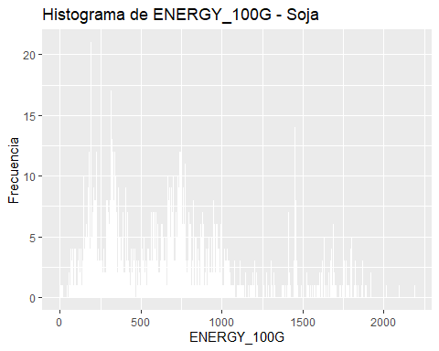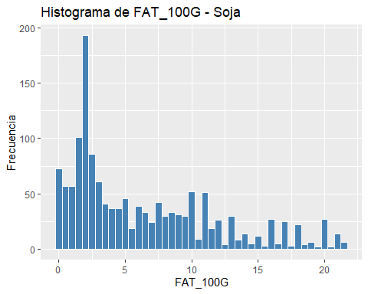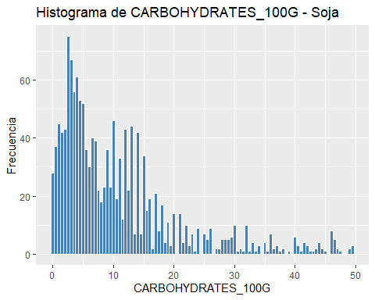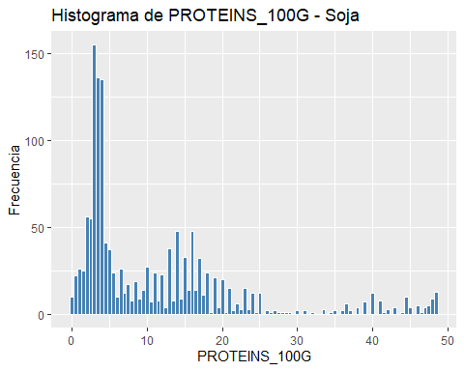

summary(as.data.frame(scale(df_soja[,-1:-2])))

## ENERGY_100G FAT_100G CARBOHYDRATES_100G PROTEINS_100G   
## Min. :-1.4580 Min. :-1.1494 Min. :-1.0577 Min. :-0.9906   
## 1st Qu.:-0.7622 1st Qu.:-0.7884 1st Qu.:-0.7143 1st Qu.:-0.6950   
## Median :-0.1284 Median :-0.3371 Median :-0.3121 Median :-0.4711   
## Mean : 0.0000 Mean : 0.0000 Mean : 0.0000 Mean : 0.0000   
## 3rd Qu.: 0.4946 3rd Qu.: 0.6557 3rd Qu.: 0.3158 3rd Qu.: 0.4424   
## Max. : 3.4788 Max. : 2.7135 Max. : 3.8083 Max. : 3.3531

#Datos normalizados para el soja

s_soja <- as.data.frame(scale(df_soja[,-1:-2]))  
# Obtener las columnas cuantitativas del dataframe  
columnas_cuantitativas <- sapply(s_soja, is.numeric)  
  
# Crear un histograma para cada columna cuantitativa  
for (columna in names(s_soja[columnas_cuantitativas])) {  
 plot_data <- s_soja[, columna]  
 p <- ggplot(data.frame(x = plot_data), aes(x)) +  
 geom_histogram(binwidth = 0.5, fill = "steelblue", color = "white") +  
 labs(title = paste("Histograma de", columna,"- Soja"),  
 x = columna,  
 y = "Frecuencia")  
   
 print(p)  
}

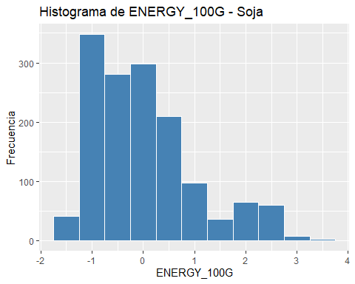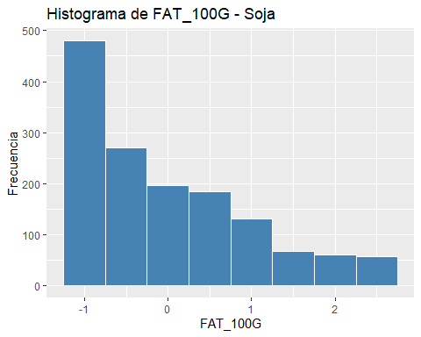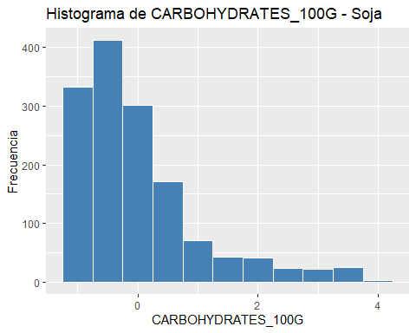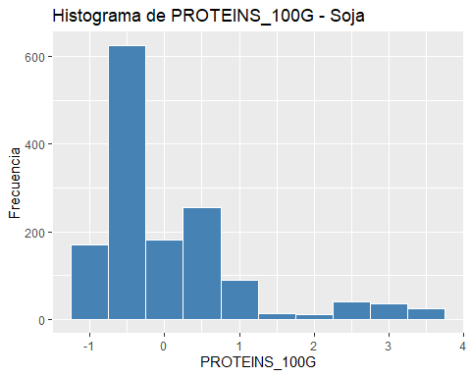

s_soja <- scale(df_soja[,-1:-2])  
  
# total de cluster óptimos  
elbow <- fviz_nbclust(x = s_soja, FUNcluster = kmeans, method = "wss", k.max = 15,   
 diss = get_dist(s_soja, method = "euclidean"), nstart = 25)  
print(elbow)

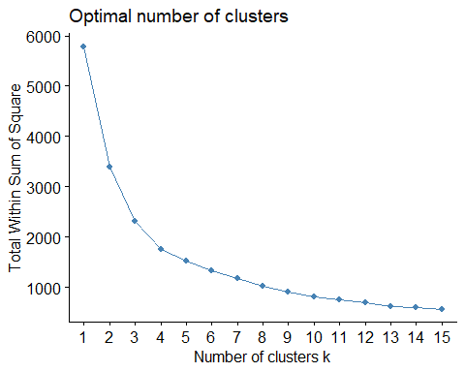

# set.seed(123)  
# km_clusters <- kmeans(x=s_soja,centers=4,nstart=25)  
# fviz_cluster(object=km_clusters,data=s_soja,show.clust.cent = TRUE,  
# ellipse.type="euclid",star.plot=TRUE,repel=TRUE,  
# pointsize=0.5,outlier.color="darkred") +  
# labs(title ="Resultados clustering K-means") +  
# theme_bw() +  
# theme(legend.position = "none")  
  
set.seed(123)  
km_clusters <- kmeans(x = s_soja, centers = 4, nstart = 50)  
  
fviz_cluster(object = km_clusters, data = s_soja, show.clust.cent = TRUE,  
 ellipse.type = "euclid", star.plot = TRUE, repel = TRUE,  
 pointsize = 0.5, outlier.color = "darkred", geom = "point") +  
 theme_bw() +  
 theme(legend.position = "none") +  
 ggtitle("Resultados clustering K-means - Soja")

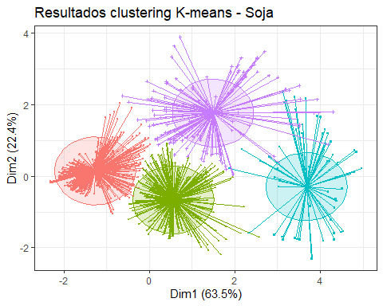

set.seed(101)  
hc_euclidea_av <- hclust(d = dist(x = s_soja, method = "euclidean"),  
 method = "average")  
fviz_dend(x = hc_euclidea_av, k = 4, cex = 0.5,  
 k_colors = c("red","blue","green","magenta"),color_labels_by_k = T,  
 lwd = 0.2,type = "r",label_cols = rainbow(nrow(df_soja)),  
 rect_lty = "lightblue") +  
 geom_hline(yintercept = 3.65, linetype = "dashed") +  
 labs(title = "Herarchical clustering Soja",  
 subtitle = "Distancia euclidea, Average, k=4")

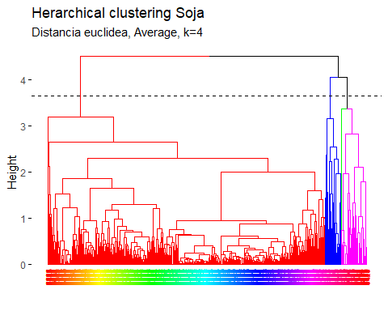

pam.res <- pam(s_soja, 4)  
# Visualización  
fviz_cluster(pam.res, geom = "point", ellipse.type = "norm",  
 show.clust.cent = TRUE,star.plot = TRUE)+  
 labs(title = "Resultados clustering K-means superpuesto Soja")+ theme_bw()

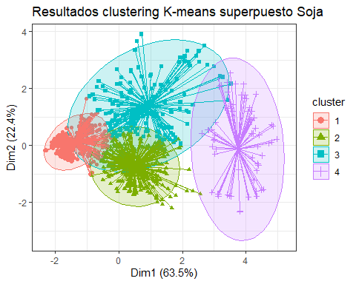 # Biplot PCA y K-Means para medir representatividad soja

# PCA  
pca <- prcomp(df_soja[,-1:-2], scale=TRUE)  
df_soja.pca <- pca$x  
# Cluster over the three first PCA dimensions  
kc <- kmeans(df_soja.pca[,1:3], 4)  
fviz_pca_biplot(pca, label="var", habillage=as.factor(kc$cluster)) +  
 labs(color=NULL) + ggtitle("") +  
 theme(text = element_text(size = 15),  
 panel.background = element_blank(),   
 panel.grid.major = element_blank(),  
 panel.grid.minor = element_blank(),  
 axis.line = element_line(colour = "black"),  
 legend.key = element_rect(fill = "white"))

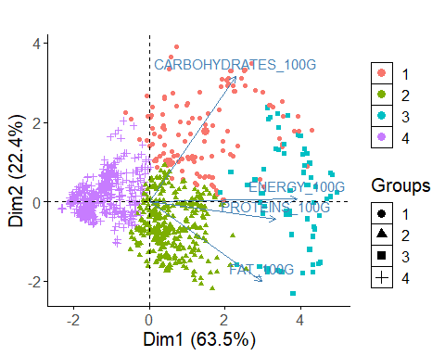

library(ggplot2)  
  
# Obtener los centroides de cada clúster  
centroids <- as.data.frame(km_clusters$centers)  
  
  
# Obtener el valor mínimo y máximo en el dataframe  
min_value <- min(centroids, na.rm = TRUE)  
max_value <- max(centroids, na.rm = TRUE)  
  
# Escalar los datos entre 0 y 1  
scaled_df <- (centroids - min_value) / (max_value - min_value)  
  
library(fmsb)  
  
  
# Define the variable ranges: maximum and minimum  
max_min <- data.frame(  
 ENERGY_100G = c(1, 0), FAT_100G = c(1, 0), CARBOHYDRATES_100G = c(1, 0),PROTEINS_100G = c(1, 0)  
)  
rownames(max_min) <- c("Max", "Min")  
  
# Bind the variable ranges to the data  
df <- rbind(max_min, scaled_df)

create_beautiful_radarchart <- function(data, color = "#00AFBB",   
 vlabels = colnames(data), vlcex = 0.7,  
 caxislabels = NULL, title = NULL, ...){  
 radarchart(  
 data, axistype = 1,  
 # Customize the polygon  
 pcol = color, pfcol = scales::alpha(color, 0.3), plwd = 2, plty = 1,  
 # Customize the grid  
 cglcol = "grey", cglty = 1, cglwd = 0.8,  
 # Customize the axis  
 axislabcol = "grey",   
 # Variable labels  
 vlcex = vlcex, vlabels = vlabels,  
 caxislabels = caxislabels, title = title, ...  
 )  
}

# Reduce plot margin using par()  
op <- par(mar = c(1, 2, 2, 1))  
create_beautiful_radarchart(df, caxislabels = c(0, .25, .5, .75, 1))

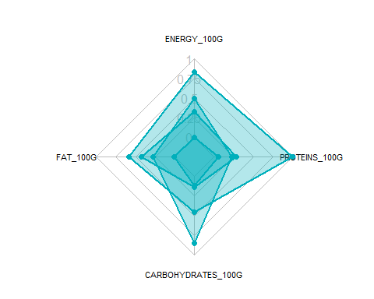

par(op)

# Reduce plot margin using par()  
op <- par(mar = c(1, 2, 2, 2))  
# Create the radar charts  
create_beautiful_radarchart(  
 data = df, caxislabels = c(0, .25, .5, .75, 1),  
 color = c("#00AFBB", "#E7B800", "#FC4E07","#7A378B")  
)  
# Add an horizontal legend  
legend(  
 x = "bottom", legend = rownames(df[-c(1,2),]), horiz = TRUE,  
 bty = "n", pch = 20 , col = c("#00AFBB", "#E7B800", "#FC4E07","#7A378B"),  
 text.col = "black", cex = 1, pt.cex = 1.5  
 )

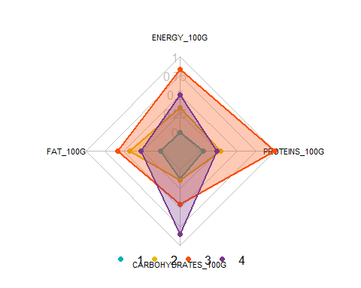

par(op)

# Define colors and titles  
colors <- c("#00AFBB", "#E7B800", "#FC4E07","blue")  
titles <- c("1", "2", "3","4")  
  
# Reduce plot margin using par()  
# Split the screen in 3 parts  
op <- par(mar = c(1, 1, 1, 1))  
  
par(mfrow = c(1,4))  
  
# Create the radar chart  
for(i in 1:4){  
 create_beautiful_radarchart(  
 data = df[c(1, 2, i+2), ], caxislabels = c(0, .25, .5, .75, 1),  
 color = colors[i], title = titles[i]  
 )  
}

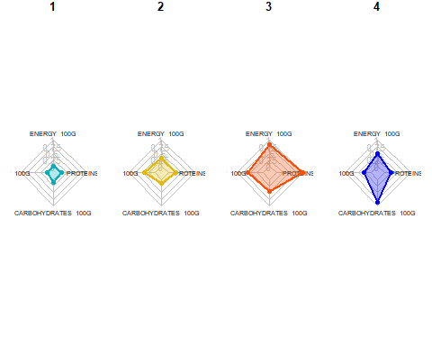

par(op)

# Visualizar los productos más cercanos al centroide que representan cada cluster top10

# Realizar clustering en el dataframe  
set.seed(123)  
df_top <- df_soja  
km_clusters <- kmeans(x = df_top[, c("ENERGY_100G", "FAT_100G", "CARBOHYDRATES_100G", "PROTEINS_100G")], centers = 4, nstart = 50)  
  
# Obtener las asignaciones de clúster  
cluster_assignments <- km_clusters$cluster  
  
# Agregar las asignaciones de clúster al dataframe  
df_top$cluster <- cluster_assignments  
  
# Inicializar una lista para almacenar los productos más cercanos a cada centroide  
closest_products <- vector("list", max(cluster_assignments))  
  
# Encontrar los productos más cercanos a cada centroide  
for (cluster in 1:max(cluster_assignments)) {  
 cluster_center <- km_clusters$centers[cluster, ]  
 distances <- apply(df_top[, c("ENERGY_100G", "FAT_100G", "CARBOHYDRATES_100G", "PROTEINS_100G")], 1, function(row) {  
 sum((row - cluster_center)^2)  
 })  
 closest_products[[cluster]] <- head(order(distances), 10)  
}  
  
# Imprimir los productos más cercanos a cada centroide  
for (cluster in 1:max(cluster_assignments)) {  
 cat("Cluster", cluster, ":\n")  
 print(df_top[closest_products[[cluster]], c("PRODUCT_NAME", "ENERGY_100G", "FAT_100G", "CARBOHYDRATES_100G", "PROTEINS_100G")])  
 cat("\n")  
}

## Cluster 1 :  
## PRODUCT_NAME ENERGY_100G FAT_100G CARBOHYDRATES_100G  
## 2895 BOULETTES DE SOJA ET TOMATES 262 1.5 6.3  
## 3165 SOJA FERMENTADA 264 2.3 6.4  
## 3062 SO SOJA ! BANANE-PASSION 259 2.0 7.0  
## 4772 GULASCH VEGAN MIT SOJA 259 1.1 6.5  
## 6816 SOJA 264 0.0 7.0  
## 4467 SHOYU SOJASOSSE AUS JAPAN 259 0.1 6.2  
## 4977 16G PROTEIN OHNE SOJA 268 0.3 8.8  
## 9278 T SOJAJOOK SHOKOLAADI 255 1.9 7.3  
## 4338 SHOYU - SOJASOSSE JAPANISCHE ART 267 0.2 5.2  
## 3109 SOJA MANGO 272 2.2 7.2  
## PROTEINS_100G  
## 2895 4.0  
## 3165 4.1  
## 3062 3.6  
## 4772 4.0  
## 6816 8.7  
## 4467 8.8  
## 4977 6.4  
## 9278 3.2  
## 4338 10.0  
## 3109 3.9  
##   
## Cluster 2 :  
## PRODUCT_NAME ENERGY_100G FAT_100G  
## 2513 CROQ' SOJA, POMME DE TERRE & EMMENTAL 674 8.1  
## 5030 SOJA SCHNETZEL 674 10.0  
## 3584 GALETTES DE SOJA RECETTE MEDITERRANEENNE 678 7.6  
## 3619 BURGERS BLE, SOJA 674 5.9  
## 7561 STRACCETTI DI SOJA 678 10.0  
## 4040 BOULE DE SOJA ENROBEE CARAMEL CACAHUETE 678 6.8  
## 3022 STEAK DE SOJA TOMATE MOZZARELLA 674 6.5  
## 4755 CROQ’ SOJA PROVENÇALE 669 8.2  
## 1899 CROQ SOJA A LA PROVENCALE 669 8.2  
## 2679 LES CROQ SOJA A LA PROVENÇALE 669 8.2  
## CARBOHYDRATES_100G PROTEINS_100G  
## 2513 7.2 13.0  
## 5030 5.7 9.5  
## 3584 8.6 13.0  
## 3619 8.5 16.0  
## 7561 5.7 9.5  
## 4040 10.0 15.0  
## 3022 6.5 16.7  
## 4755 4.0 14.0  
## 1899 4.0 14.0  
## 2679 4.0 14.0  
##   
## Cluster 3 :  
## PRODUCT_NAME ENERGY_100G FAT_100G  
## 4876 MELANGE DE CEREALES AU SOJA 1611 11.0  
## 4789 SOJAMEHL 1600 19.0  
## 2508 LES CUISINES VEGGIE - COUSCOUS AUX EMINCES SOJA & BLE 1602 5.9  
## 3311 SOJA NOIR 1594 15.9  
## 4752 SOJAKERNE 1602 18.0  
## 3260 SOJA JAUNE 1615 18.3  
## 3258 SOJA JAUNE 1618 18.3  
## 2080 FLOCONS DE SOJA 1619 18.0  
## 6851 SOJA FLOCKEN 1619 18.0  
## 1171 FETTUCCINE AU SOJA BIOLOGIQUES 1590 6.0  
## CARBOHYDRATES_100G PROTEINS_100G  
## 4876 34.0 30.0  
## 4789 18.0 35.0  
## 2508 25.0 20.0  
## 3311 33.6 36.0  
## 4752 6.3 38.0  
## 3260 6.3 38.2  
## 3258 6.3 38.2  
## 2080 6.0 40.0  
## 6851 6.0 40.0  
## 1171 40.0 40.0  
##   
## Cluster 4 :  
## PRODUCT_NAME ENERGY_100G  
## 5624 LA PANEE SOJA ET BLE 981  
## 6864 LA PANEE SOJA ET BLE 981  
## 6689 GARDEN GOURMET LA PANEE SOJA ET BLE 180G 984  
## 6701 GARDEN GOURMET LA PANEE SOJA ET BLE FORMAT FAMILIAL 360G 984  
## 3231 BURGER VEGETARIEN STEAK SOJA ET MOZZARELLA 980  
## 2496 GRILL VEGETAL - NUGGETS SOJA & BLE 975  
## 6441 NUGGETS SOJA & BLE 975  
## 5718 BURGERS DE LEGUMES AU SOJA BELGE 983  
## 3390 NUGGETS SOJA ET BLE 983  
## 3597 STEAK SOJA, BLE, POIS 980  
## FAT_100G CARBOHYDRATES_100G PROTEINS_100G  
## 5624 11.66667 17.55556 12.22222  
## 6864 11.66667 17.55556 12.22222  
## 6689 11.70000 17.60000 12.30000  
## 6701 11.70000 17.60000 12.30000  
## 3231 10.00000 21.00000 13.00000  
## 2496 11.00000 14.00000 17.00000  
## 6441 11.00000 14.00000 17.00000  
## 5718 14.00000 9.20000 15.00000  
## 3390 8.00000 25.00000 13.00000  
## 3597 13.00000 8.50000 19.00000